

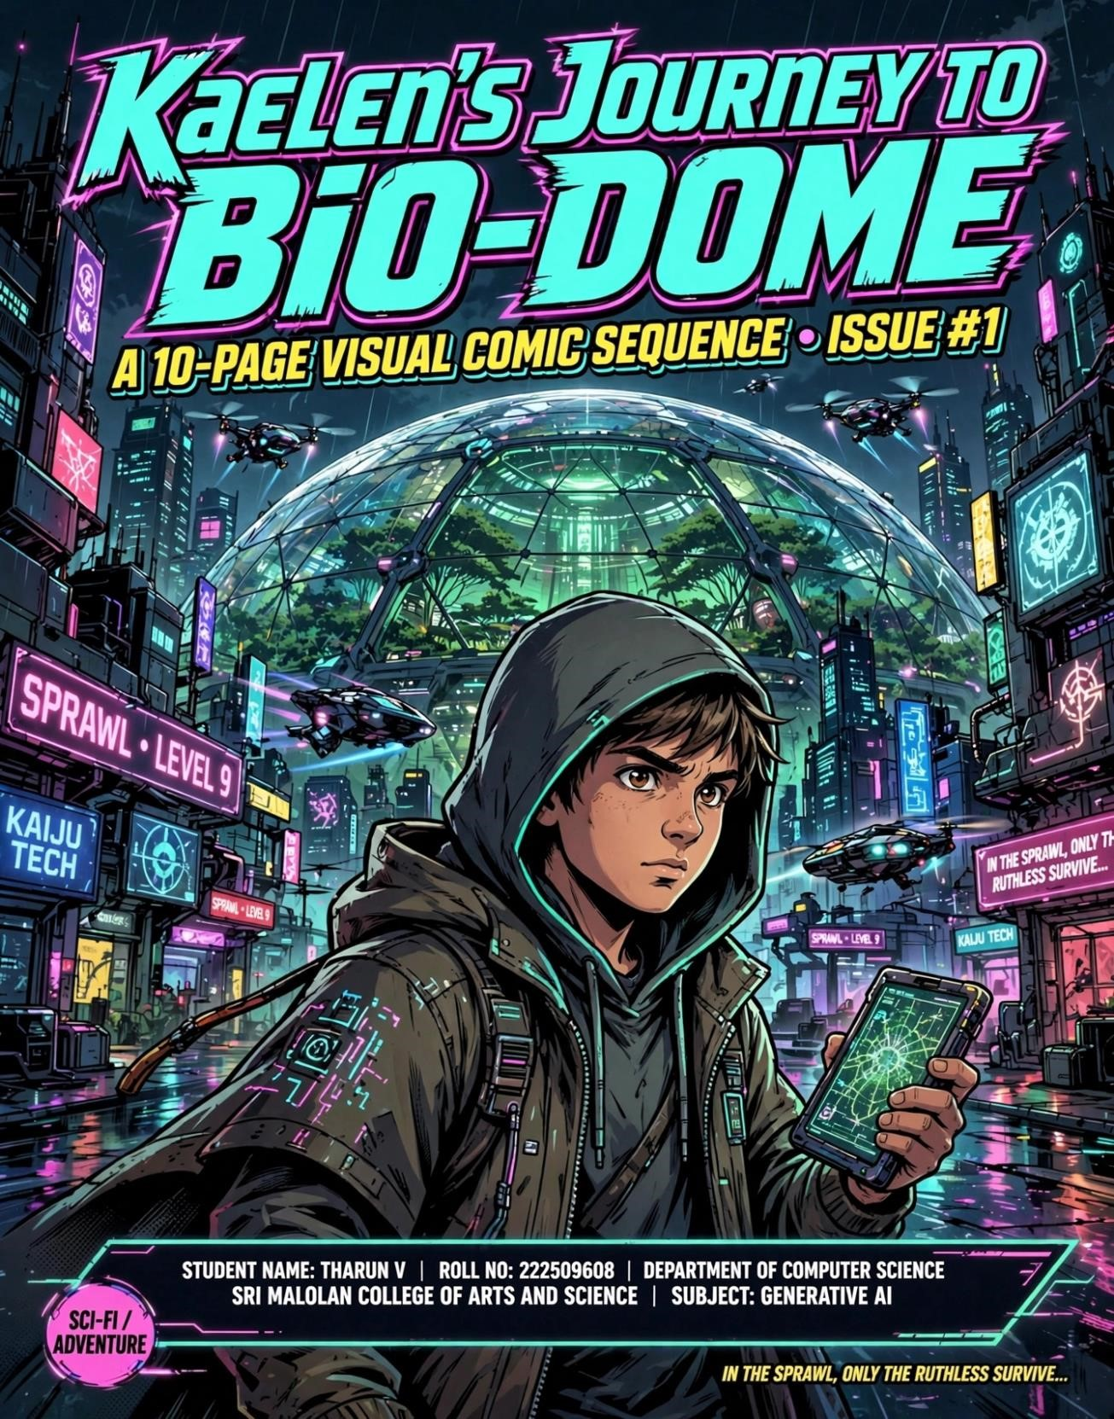
This page introduces our protagonist, Kaelen, and his routine life in the neondrenched metropolis.

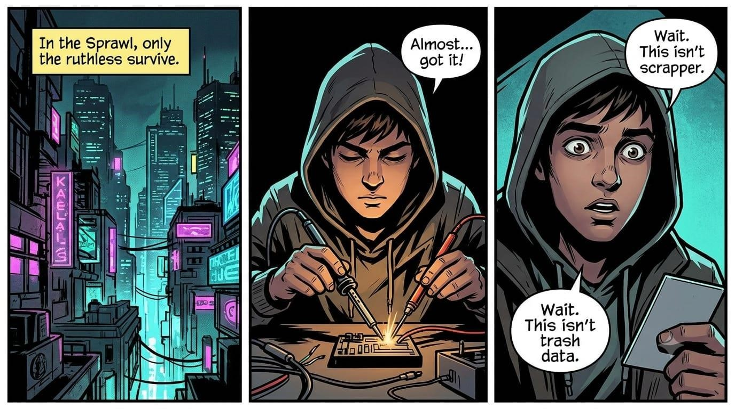
Page 2: The Discovery
Kaelen investigates the encrypted chit and discovers a map leading to something incredible: the long-lost “BioDome.”

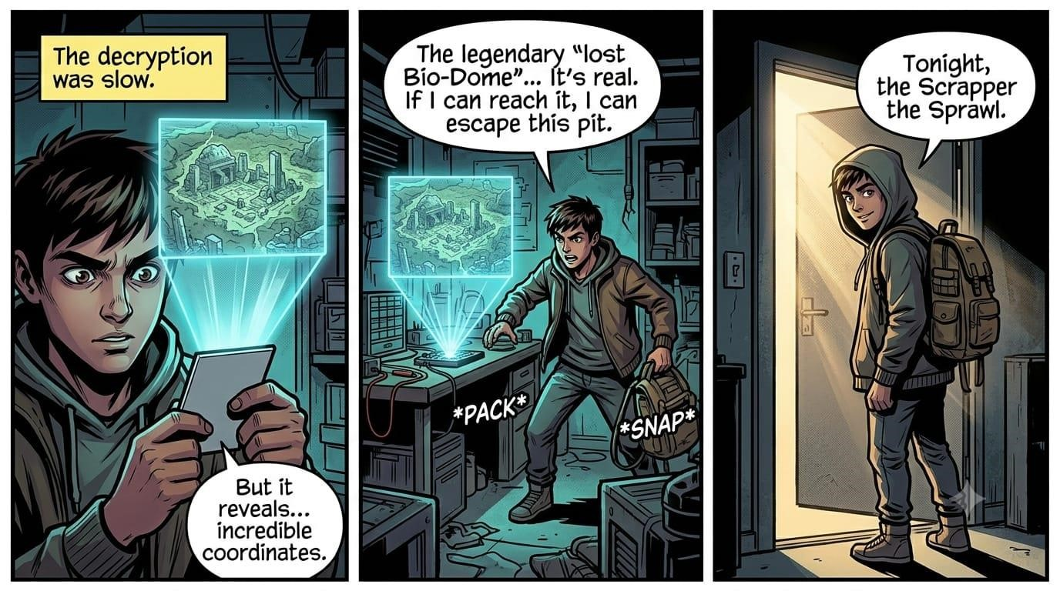
Page 3: Departure
Kaelen leaves the neon city behind, trading the artificial lights for the harsh, irradiated reality of the Wasteland.
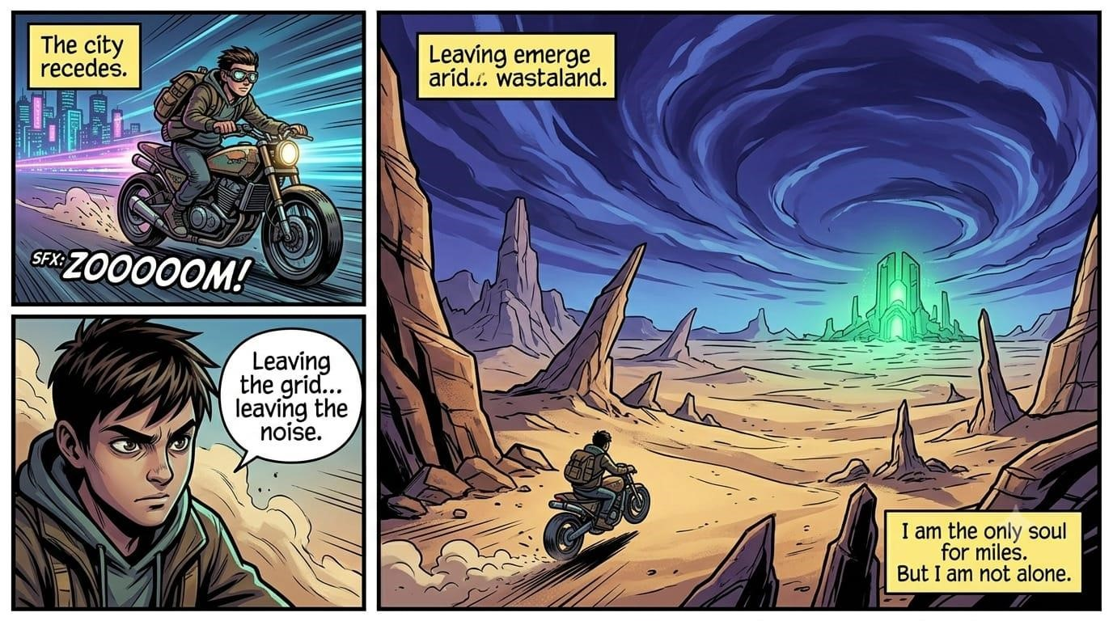

Page 4: Arrival
Kaelen arrives at the ruins but must use his scrapper skills to bypass a massive, powered stone gate blocking the entrance.

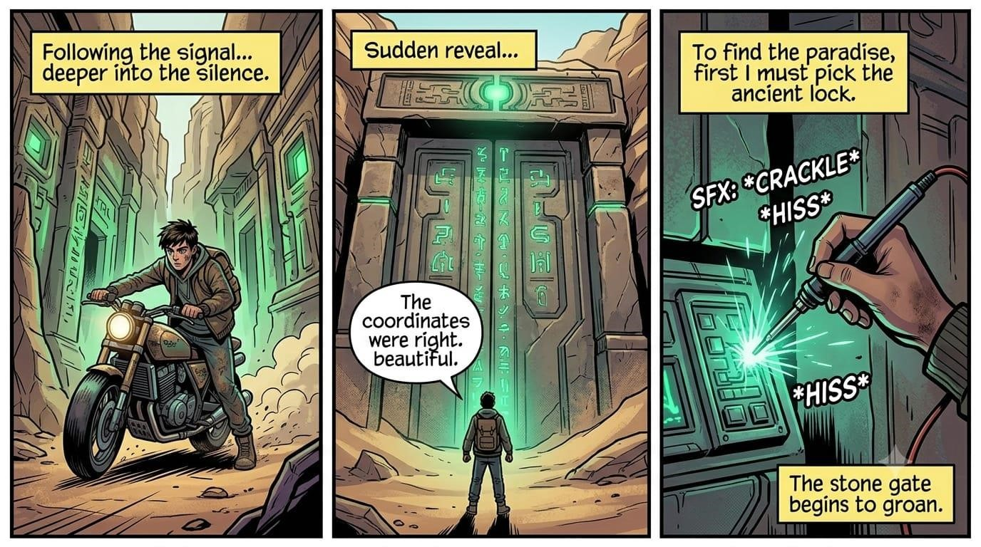
Page 5: The Bio-Dome
The gate opens, revealing a breathtaking, vibrant jungle hidden deep within the mountain—the legendary Bio-Dome itself.

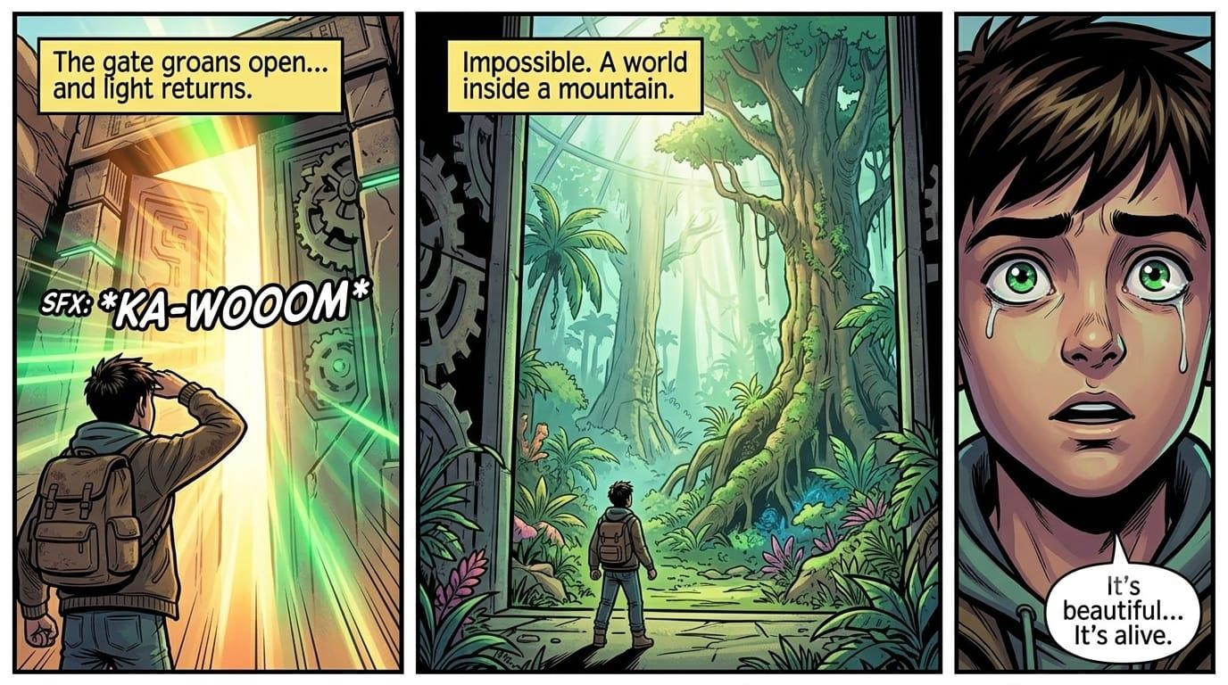

Page 6: The Caretaker
Kaelen explores the vibrant jungle, but his presence is quickly noted by the dome’s silent guardian.

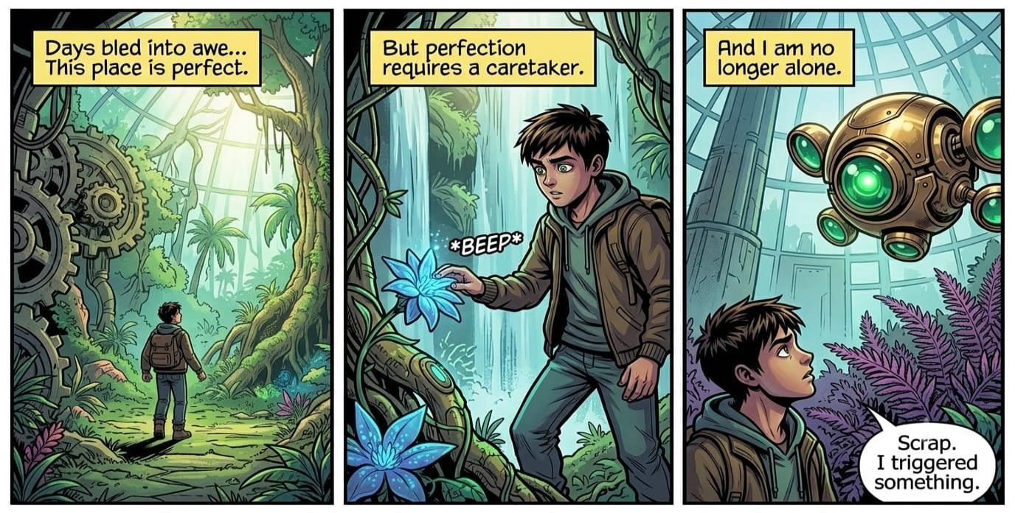

Page 7: Confrontation
The Caretaker drone confronts Kaelen, demanding authentication. Kaelen is trapped as the ancient defense systems activate.

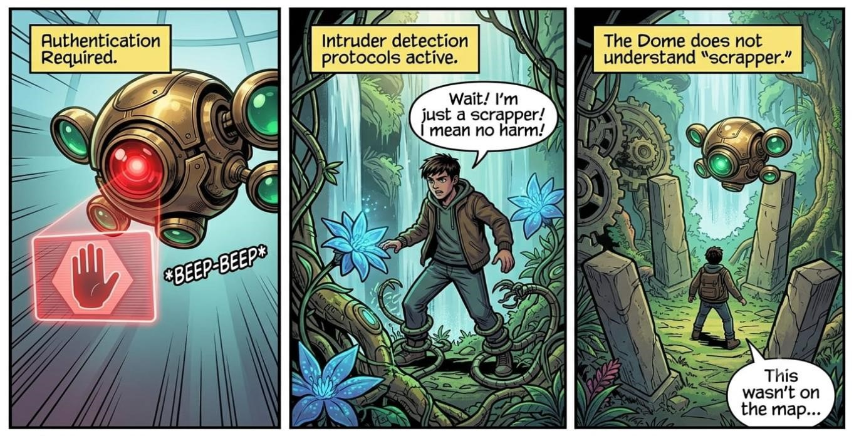

Page 8: The Offering
Kaelen is pinned. Instead of fighting, he realizes the Dome needs a specific component it cannot create. He presents the original data-chit.

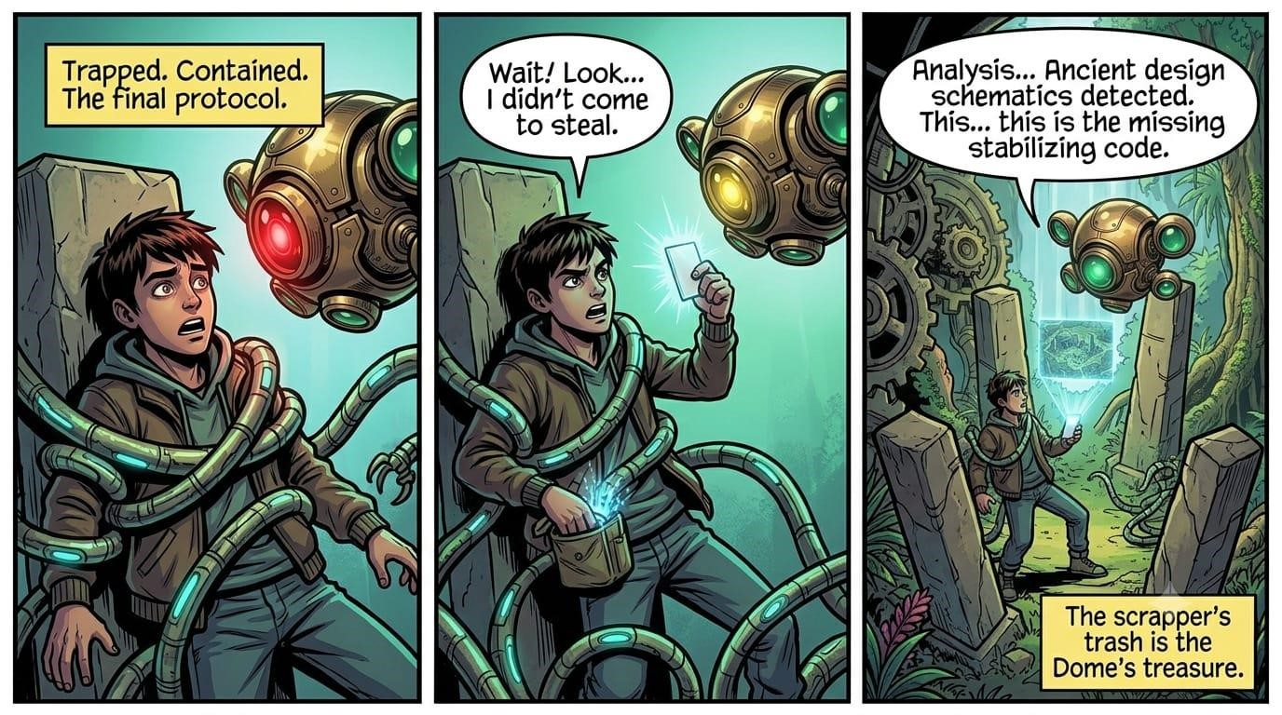

Page 9: Integration
The Caretaker drone accepts the gift. It uses the data to finally repair the Dome’s core infrastructure. The environment stabilizes and flourishes.

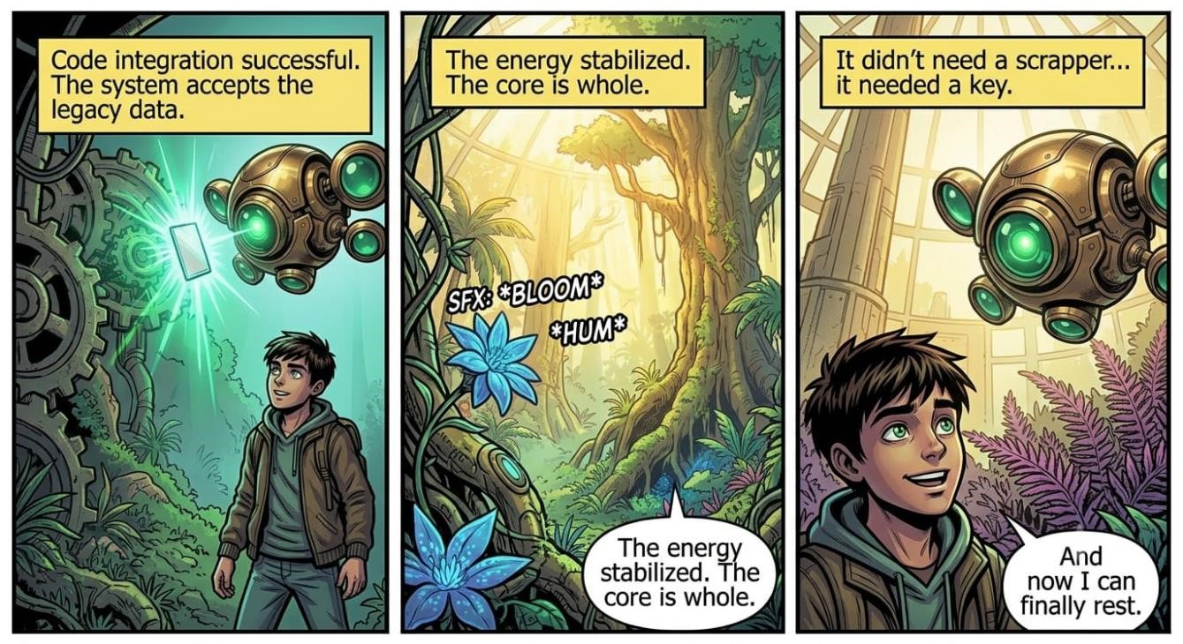

Page 10: The New Life
Kaelen is accepted by the Dome. He trading scrapping for gardening, finally finding the peace and clean air he always sought.
